**AWS 3 Tier Architecture**

How to create and test a web tier, application tier, and database tier for a highly available and scalable architecture

AWS offers comprehensive resources to build and maintain your cloud applications.

These resources can be configured to work together to create highly available, highly reliable cloud structures.

The scenario we will use is that you have been asked to design and create a highly available 3 tier architecture for your company’s new web application.

This Session is quite long, but also thorough, please pay attention in detail.

**What is a 3 Tier Architecture**

A 3-tier architecture consists of a presentation tier, an application tier, and a data tier.

The ***presentation tier***houses the user interface, such as the website that a user or client navigates to. It can also be thought of as the “front end.”

The ***application tier*** is where data is processed and is often called the “back end.”

The ***data tier***is where data is stored and managed.

**Benefits of a 3 Tier Architecture**

* ***Decreased development time***— different teams can work on different tiers simultaneously, resulting in decreased time to deploy.
* ***Increased scalability*** — a tier can have an auto-scaling group independent of other tiers, meaning for each tier, you only use what you need.
* ***Increased reliability***— each tier can have multiple resources in multiple availability zones and the success and availability of one tier is independent of the other tiers.
* ***Increased security*** — each tier can have its own security group, allowing for custom permissions depending on the needs of that tier.

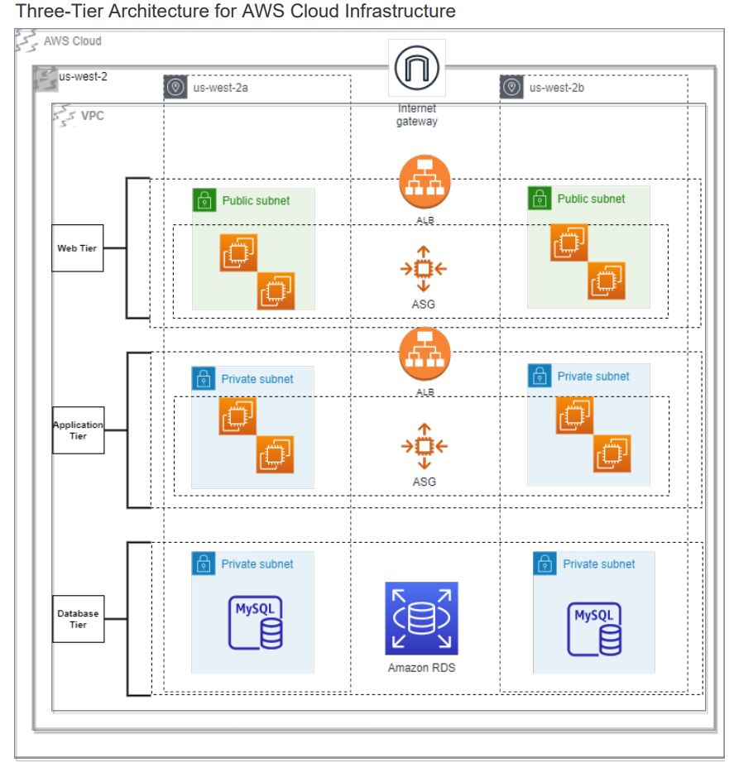

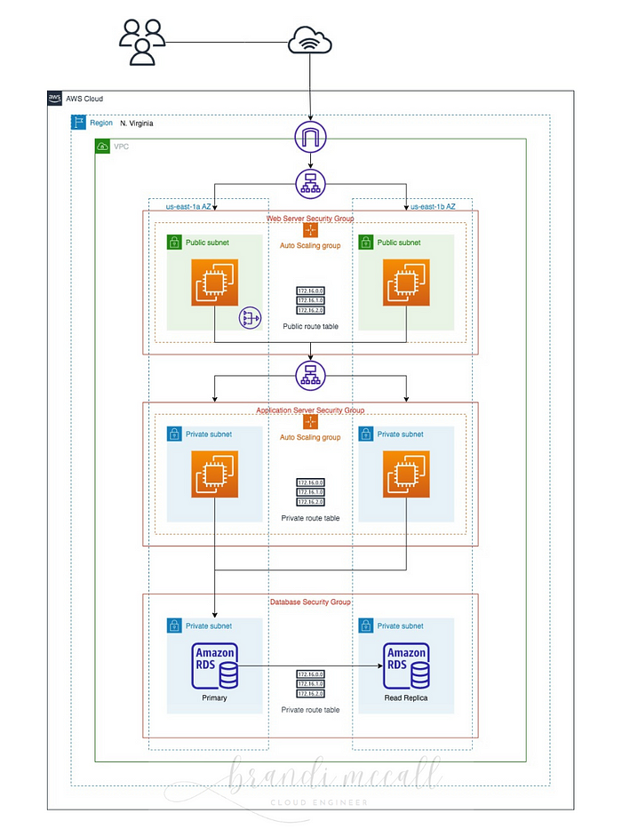

**Part 1: Creating a VPC and Subnets**

Looking at our architecture diagram, we see that we need to create 1 VPC, 2 public subnets, and 4 private subnets.

After logging into the AWS console, navigate to the VPC resource. Click “Create VPC” and here you will see two options: “VPC only” or “VPC and more.”

Because we are creating a VPC with multiple subnets, availability zones, and more, let’s choose “VPC and more.”

Feel free to use tag auto-generation, which will tag all of the resources of your VPC. This helps you to stay organized.

When creating the VPC, use the following input:

**IPv4 CIDR block:**10.0.0.0/16  
**Tenancy:** Default  
**Availability zones:** 2  
**Number of public subnets:** 2  
**Number of private subnets:** 4  
**NAT gateways:** In 1 per AZ *(there is a fee for this, so delete it when you are done)***VPC endpoints:**None  
**Enable DNS hostnames:**check  
**Enable DNS resolutions:** check

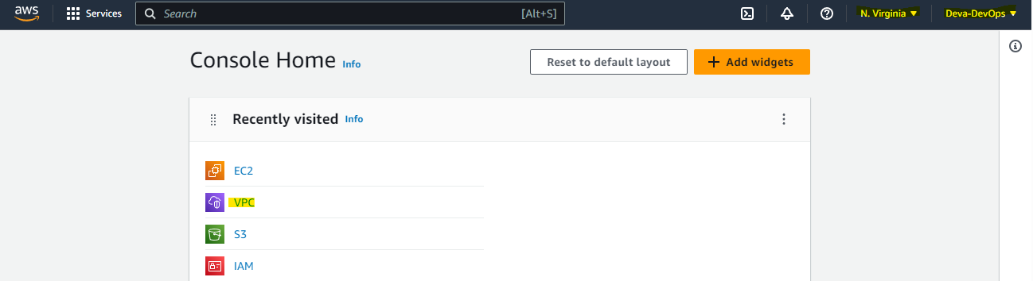

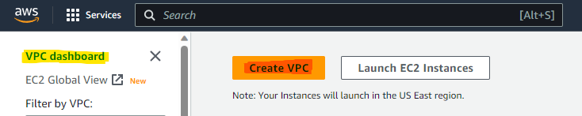

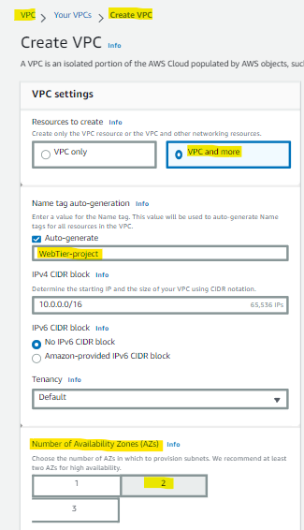

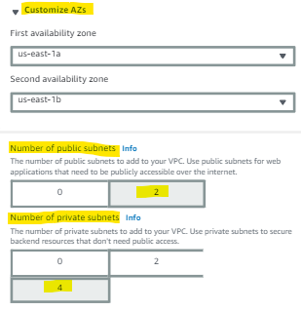

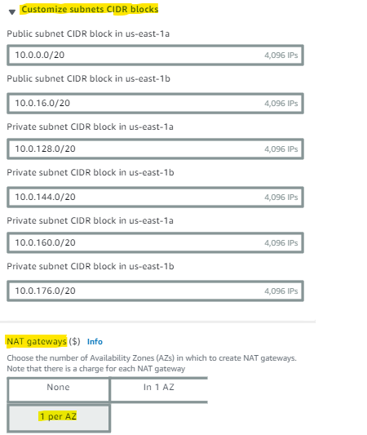

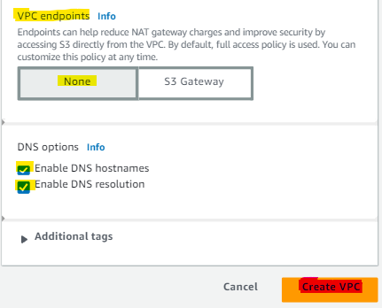

AWS has updated the VPC console to include a preview that allows you to visually see your subnets, availability zones, route tables, and network connections as you create them.

You can hover over a subnet, and it will highlight in blue the route that will occur, making it easy to see your connections.

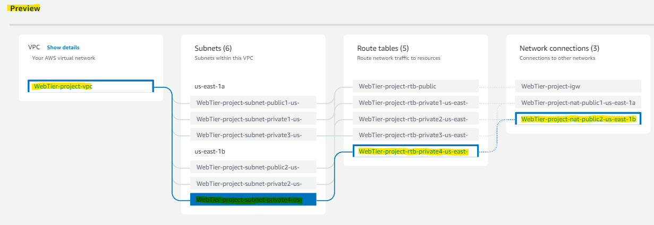

When ready, click “Create VPC.” You will get real-time updates of the workflow being created.

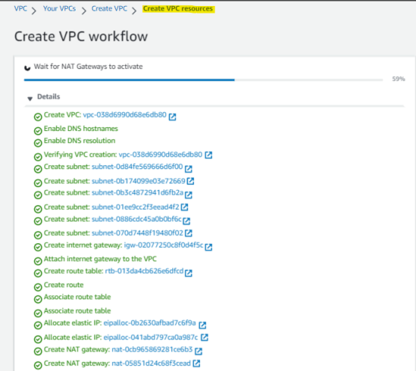

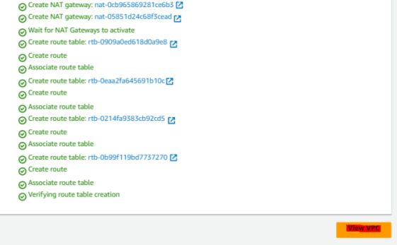

When all of your VPC resources have finished creating, click “View VPC.”

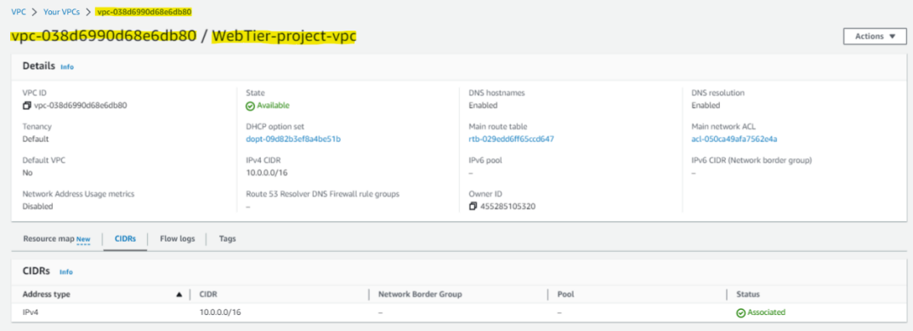

We’ve now created a VPC, 2 public subnets, 4 private subnets, 2 NAT gateways, an Internet gateway, and some default route tables.

Before we move further, navigate to “Subnets” on the left side menu of the VPC console and select one of the subnets you have created.

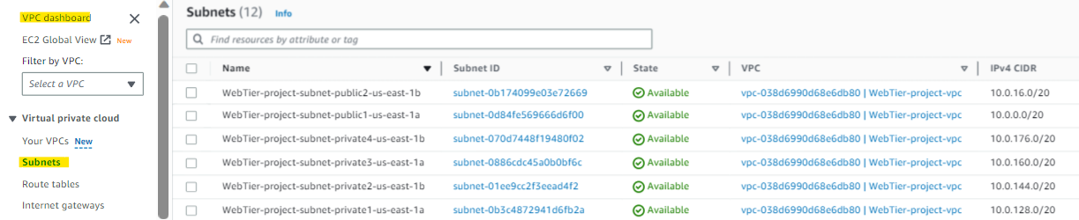

Under the “Actions” tab, expand the down arrow and select “Edit subnet settings.”

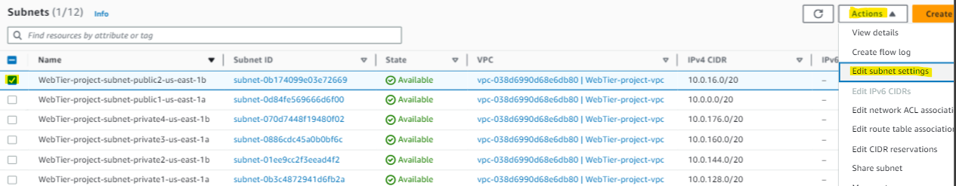

Click “Enable auto-assign IPv4 address” and “Save.” Do this for all 6 of your subnets.

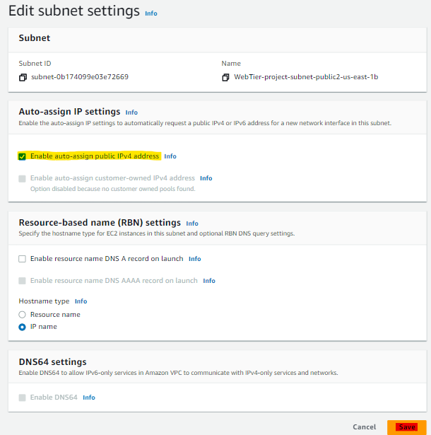

**Part 2: Creating a Web Server Tier**

In this section we will create our first tier that represents our front-end user interface. We need to create an auto scaling group of EC2 instances that will host a custom webpage for us.

**Launch an Instance**

Navigate to the EC2 console, click “Instances,” then “Launch instances.” Give the instance a name, select an AMI, select an instance type, and key pair.

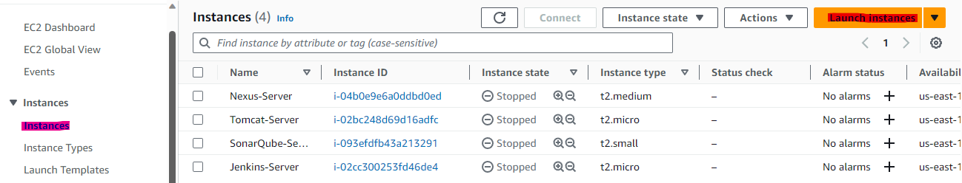

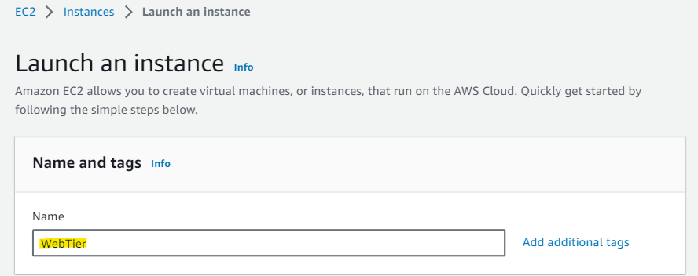

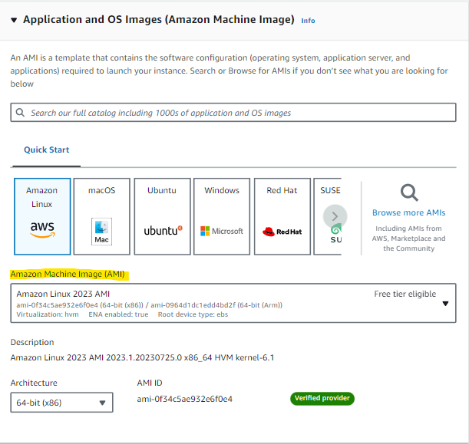

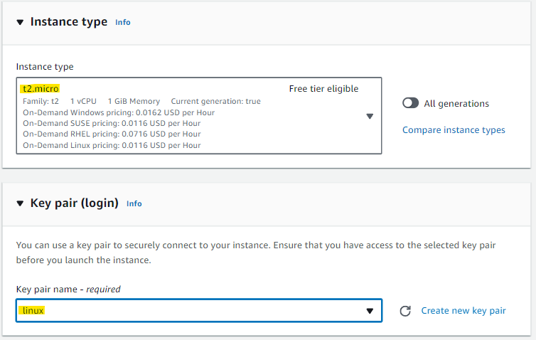

Under the Network settings you will see that the default VPC is selected. Click “Edit” and select the VPC you just created. Then select one of the public subnets you just created. For “Auto-assign public IP,” choose “Enable.”

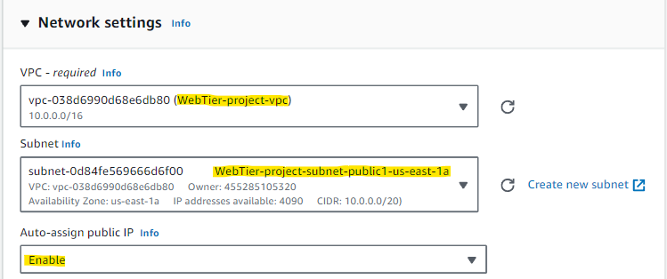

Under the Firewall settings we want to create a web tier security group that allows inbound internet traffic. Select “Create security group,” give it a name and description, and the select “HTTP” for type and “Anywhere” for source type. This will allow all inbound traffic on port 80. I also like to allow HTTPS (port 443) and SSH (port 22).

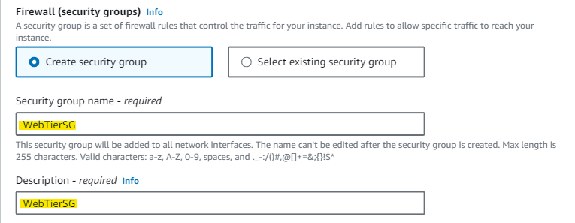

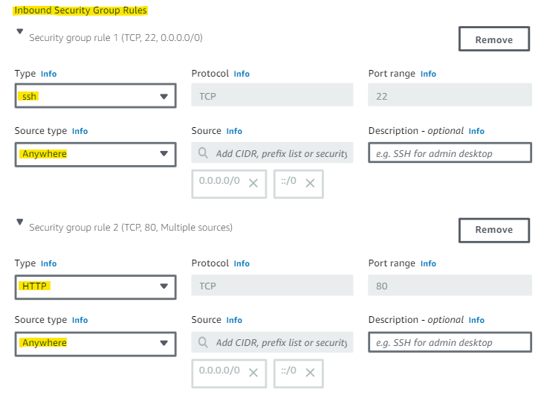

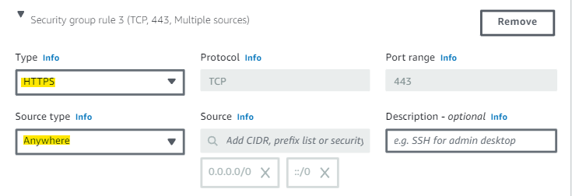

Under the Configuration storage settings, you can leave it as is.

Open the Advanced details section and scroll all the way to the bottom where you see user data.

We want our public IP address to point to a custom website. We can have Apache web server launch at the time of the instance launch by putting a script in the user data field.

The following script will install Apache and lead to a custom site that says “We have successfully launched the Web Tier!”

*#!/bin/bash*  
*yum update -y*  
*yum install -y httpd*  
*systemctl start httpd*  
*systemctl enable httpd*

*cd /var/www/html*  
*sudo echo “<html><body><h1>We have successfully launched the Web Tier!</h1></body></html>” > /var/www/html/index.html*

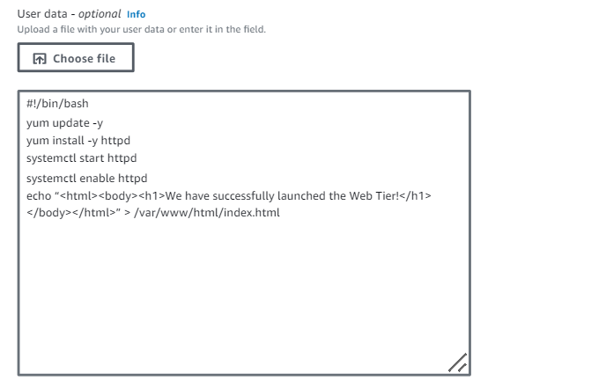

We are now ready to click “Launch instance.”

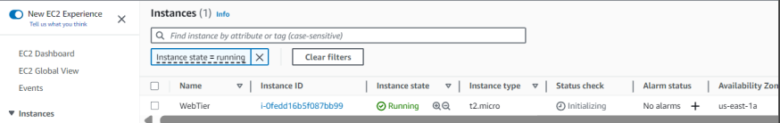

You should see that your instance is running, but this may take a few moments.

Select the running instance and copy and paste the public IPv4 address in a web browser to see if you are met with a custom webpage.

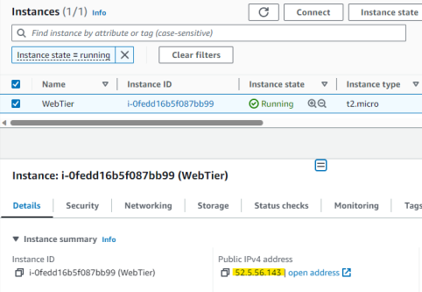

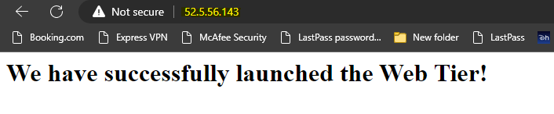

Success! Remember that most web browsers will automatically try to redirect you to the secure HTTP site. If you get an error when trying to access the public IPv4 address, make sure your URL is <http://52.5.56.143> (use your specific instance IPv4 address) and NOT <https://52.5.56.143> .

**Create a Launch Template and Auto Scaling Group**

Ok so now we have a running EC2 instance with a functioning website. We want to attach an auto scaling group to the instance to increase our availability and reliability.

When creating an auto scaling group, you need to define a launch template that tells EC2 what resources to use to launch the on-demand instances.

In the EC2 console, select “Auto Scaling Groups” from the left side bar menu, then click the orange “Create Auto Scaling group” button. Give the auto scaling group a name and click the blue “Create a launch template” link.

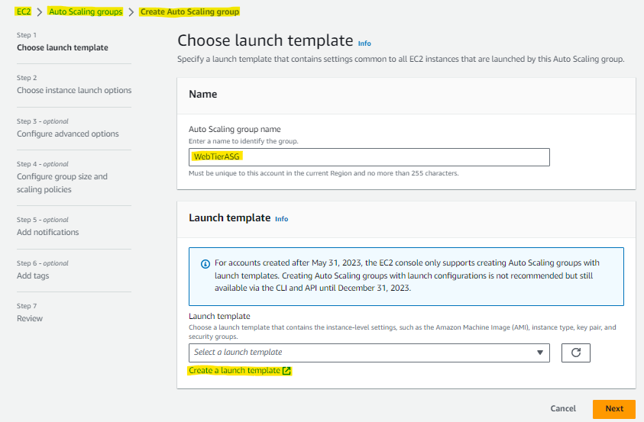

This will open a new window where you can select the specifics of your launch template.

I’m creating a template with the Amazon Linux 2 AMI and t2.micro instance type. Give the launch template a name and description.

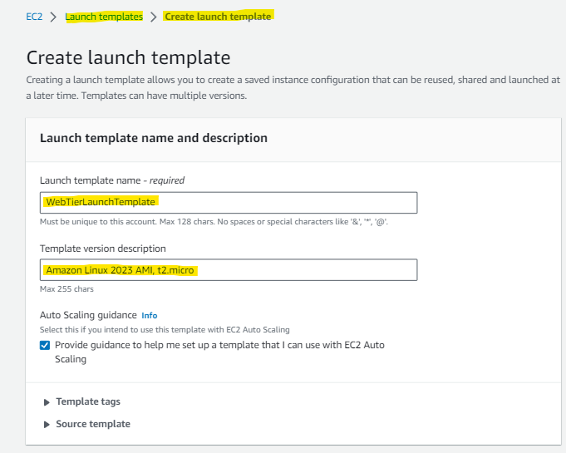

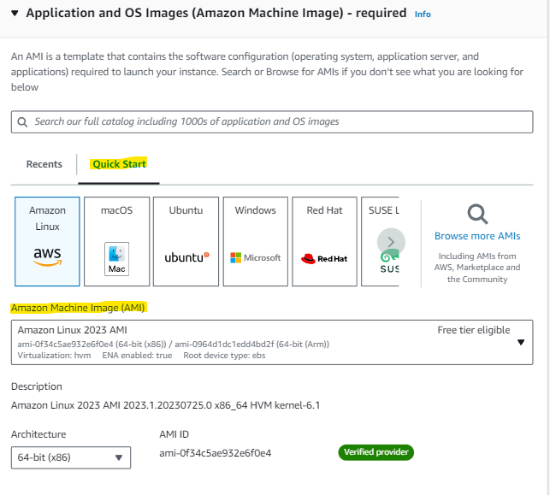

Select an existing key pair or create a new one.

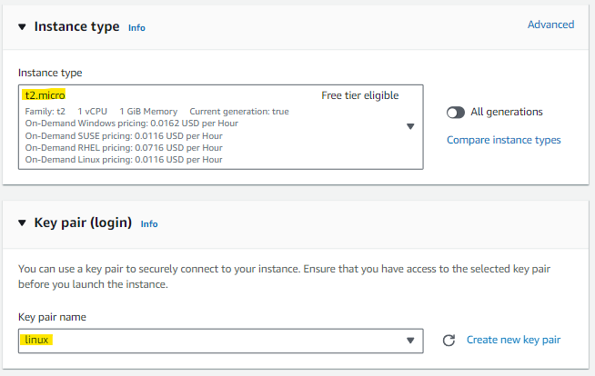

Under Network settings, select the security group that you created earlier for the web tier. You can add additional EBS volumes if desired.

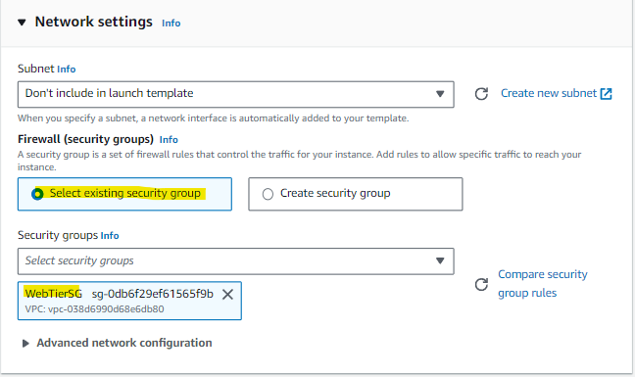

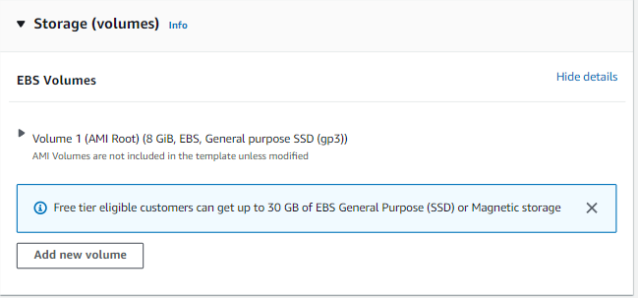

Under Advanced details, include the same user data that you did previously.

*#!/bin/bash*  
*yum update -y*  
*yum install -y httpd*  
*systemctl start httpd*  
*systemctl enable httpd*

*cd /var/www/html*  
*sudo echo “<html><body><h1>We have successfully launched the Web Tier!</h1></body></html>” > /var/www/html/index.html*

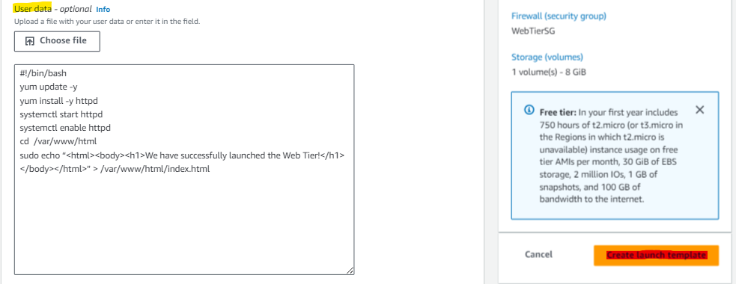

Click “Create launch template.”

Ok now, navigate back to the auto scaling group page, refresh the launch templates, then select the launch template you just created.

This launch template is the blueprint the instance will use to create additional instances when it needs to scale up. Click “Next” when ready to proceed.

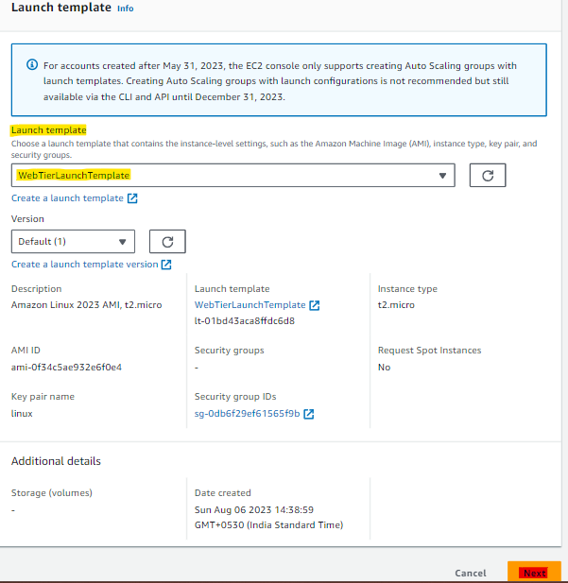

The next screen asks about network settings and has the default VPC selected.

We want our web tier auto scaling group to use the VPC we created earlier, and scale across the two public subnets that we created.

Select the appropriate VPC and subnets and click “Next.”

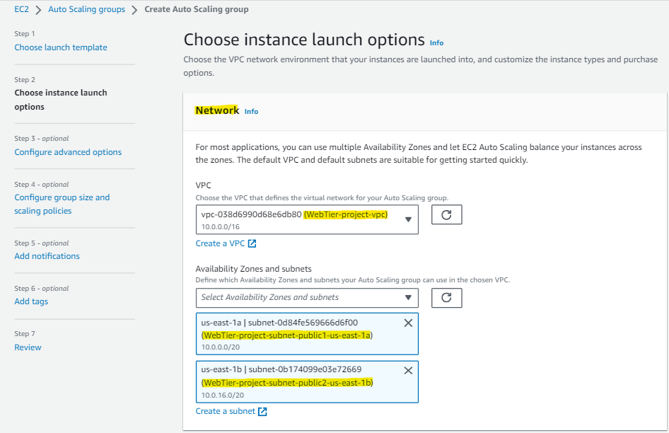

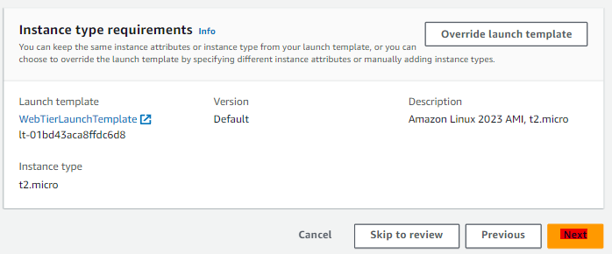

You are now given the option to add a load balancer.

A load balancer is a good idea to distribute traffic amongst the instances.

Since we haven’t created one yet, we will select “Attach to a new load balancer” and choose “Application Load Balancer” because we are using HTTP connections.

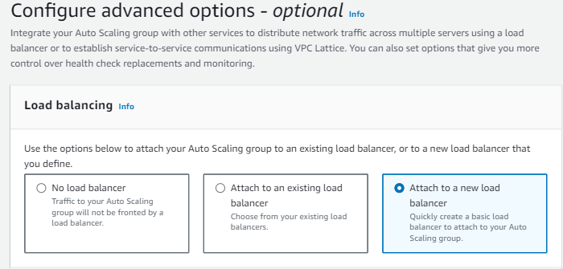

Give the load balancer a name and select “Internet-facing” for the scheme. This will allow us to communicate to the internet, not just internally.

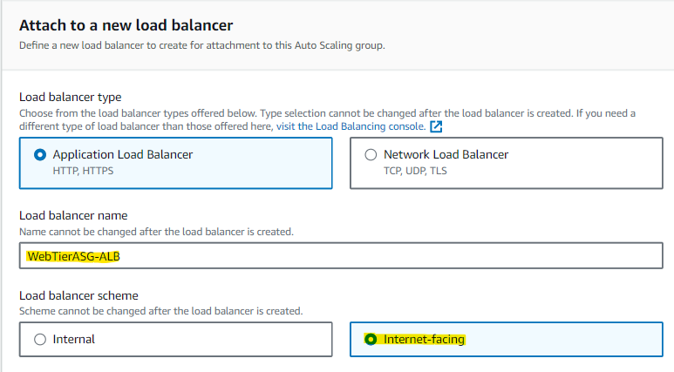

Under Network mapping, you should see the VPC that you created and the two public subnets in our auto scaling group.

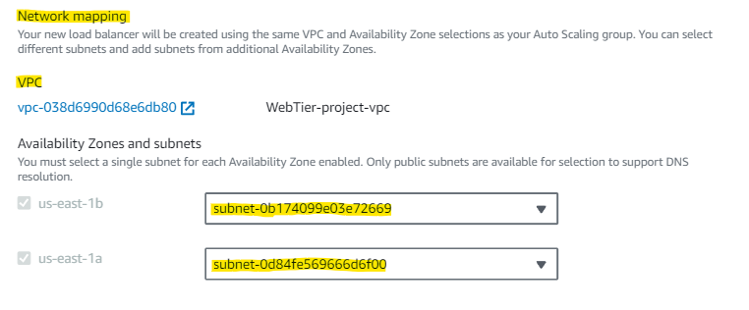

The load balancer needs a listener and target group. We can see HTTP is selected (port 80) and we will create a new target group.

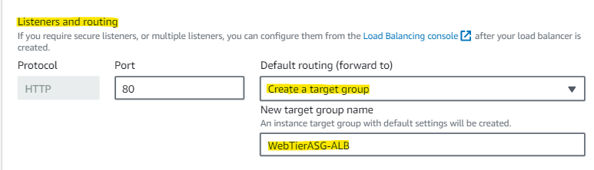

Click “ELB” under Health checks and “Enable group metrics collection within CloudWatch.” Both of these are optional settings. When ready, click “Next.”

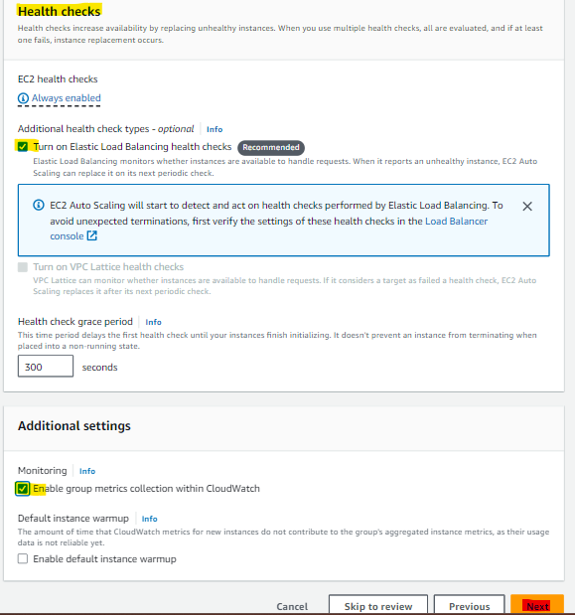

Next, we configure the group size and scaling policies.

We want a desired capacity of 1 instance, minimum capacity of 1 instance, and a maximum capacity of 2 instances.

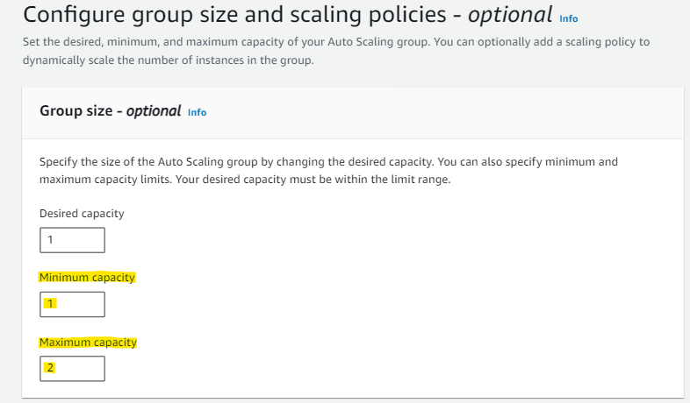

Selecting “Target tracking scaling policy” will allow you to apply a policy that resizes your Auto Scale group according to changes in demand.

You can set when you want scaling to occur based on percentage of CPU utilization. In the below example, I’ve selected “Target tracking scaling policy” to scale when the average CPU utilization reaches 50%. When you are finished adjusting these settings, click “Next.”

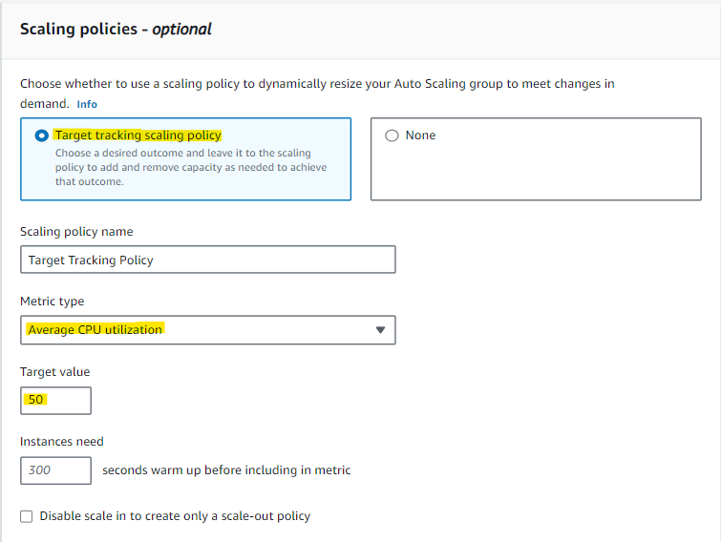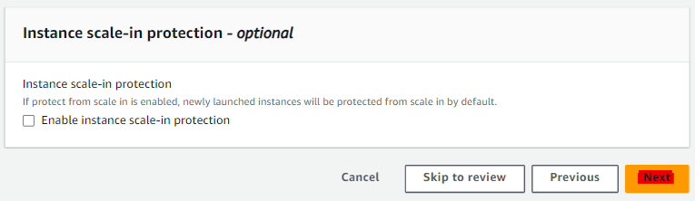

You have the option to add notifications (SNS topics) or tags, but I’ve skipped both of these. After reviewing your settings for the auto scaling group, click “Create auto scaling group.”

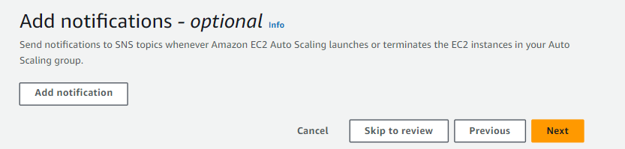

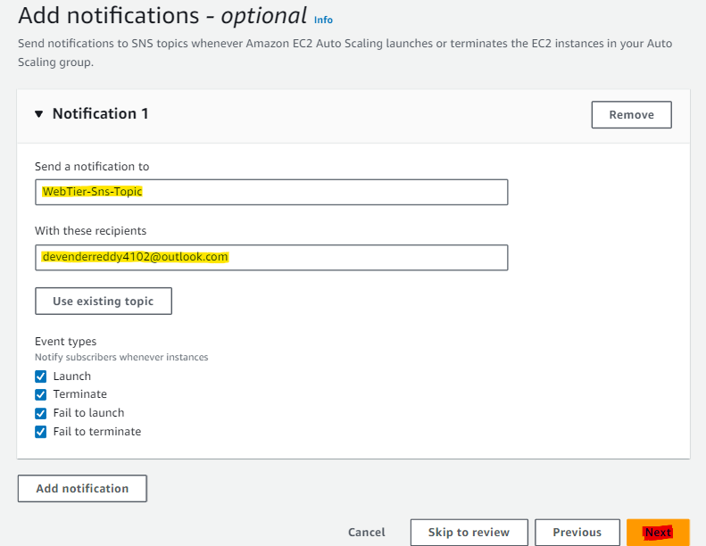

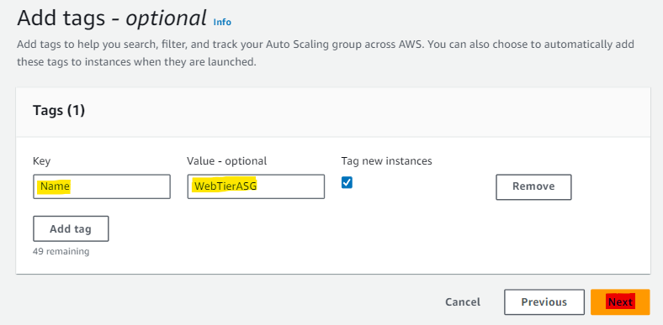

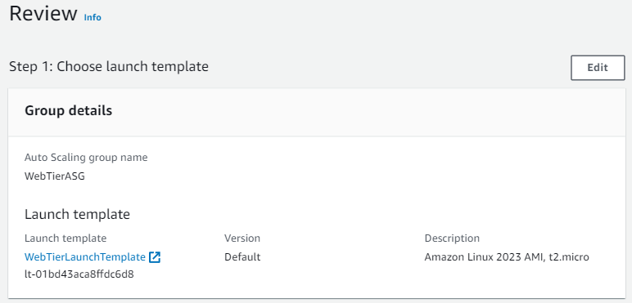 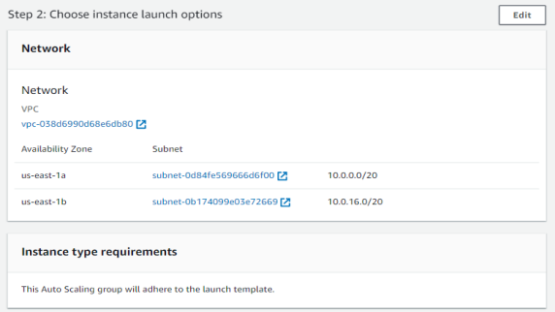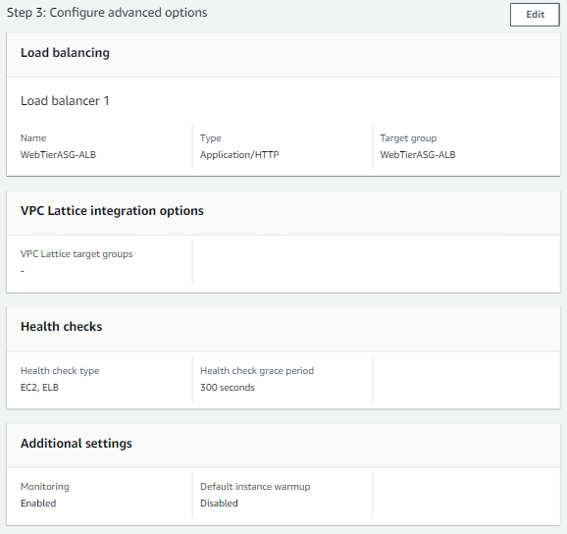 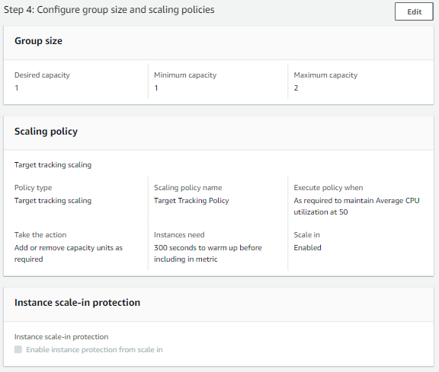

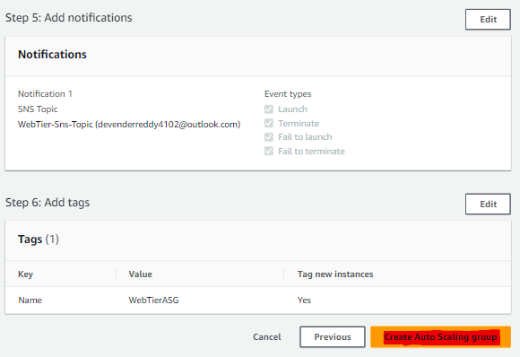

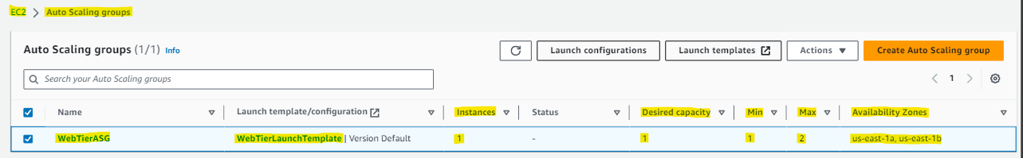



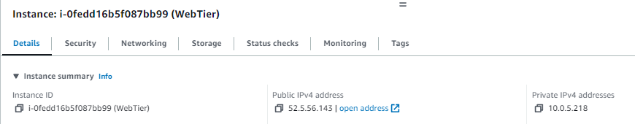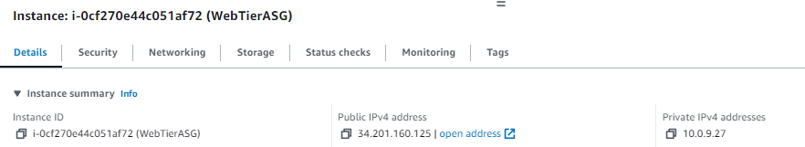

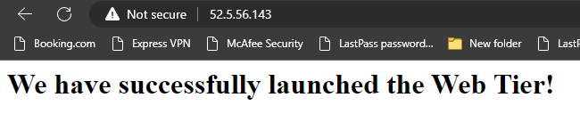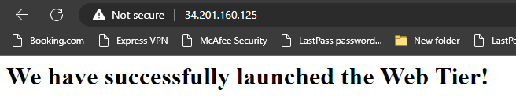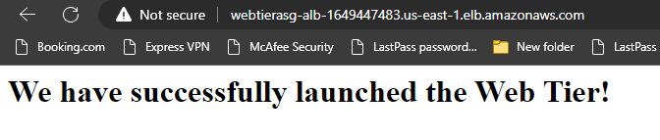

**Update Tier 1 Public Route Tables**

Ok at this point, we’ve successfully created our web tier.

We have a tier with a VPC, two public subnets with an autoscaling group, a security group, an internet gateway, and user data that will install Apache and create a custom website landing page.

***The last thing we need to do for the web tier is make sure that the route tables that were automatically created when we created the VPC and subnets are associated correctly.***

Navigate back to the VPC dashboard and on the left side menu select “Route tables.” Select the web tier public route table and view the associated subnets. It should be the two public subnets we created.

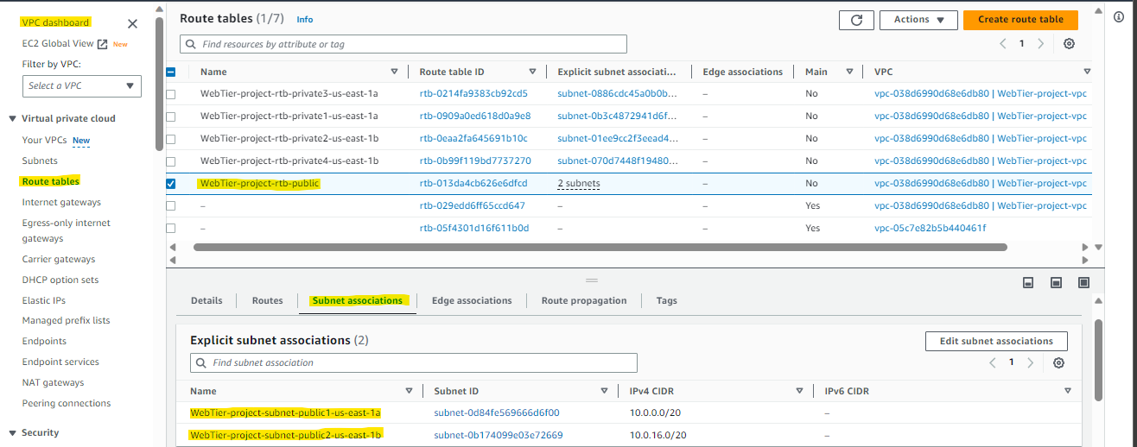

This looks correct, so our web tier is now complete.

**Part 3: Creating an Application Tier**

For the application tier, we will use the same VPC as tier 1 as well as 2 of the private subnets that we previously created.

***We want to again create an EC2 instance with an auto scaling group up to 2, and can use the same steps that we did to create our tier 1 instance and auto scaling group.***

***We are going to change up the security group permissions to limit access from the public.***

Go ahead and launch an instance using the instructions from earlier.

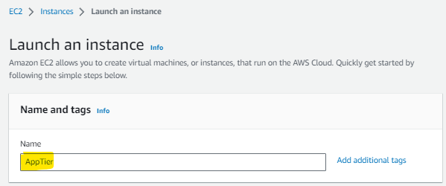

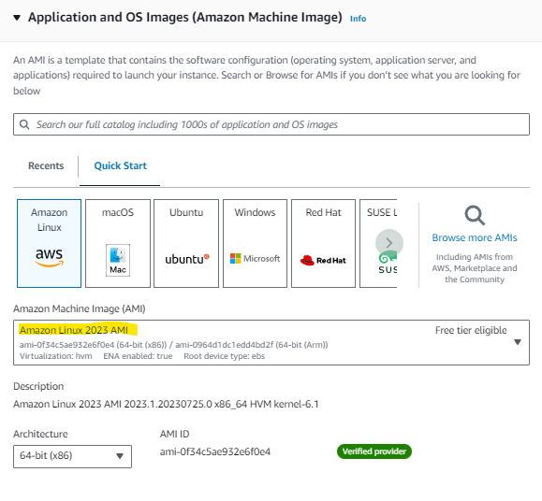

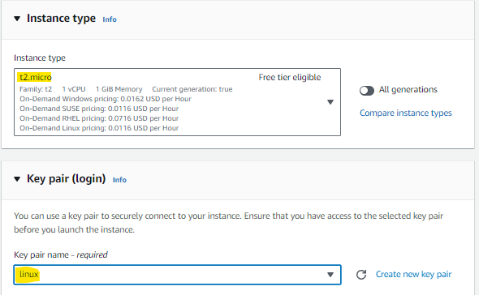

For Network settings, we want to limit access to the application tier for security purposes. You wouldn’t want any public user being able to access the application tier or back end, so we will adjust these permissions by creating a new security group.

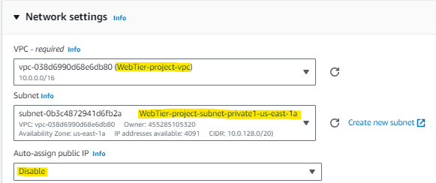

We want to allow SSH, HTTP, and ICMP traffic from our web tier security group. The ICMP rule will allow us to ping the application tier from the web tier.

When adding your security groups, choose “Custom” source type, and this will allow you to ***select your web tier security group as the source***. ***You do not need to auto-assign public IP for this tier, since it is a private subnet.***

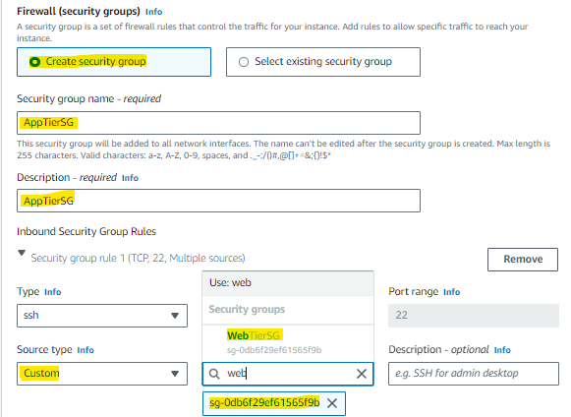

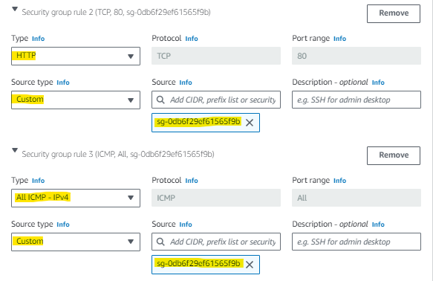

After completing the network settings, go ahead and launch the instance.

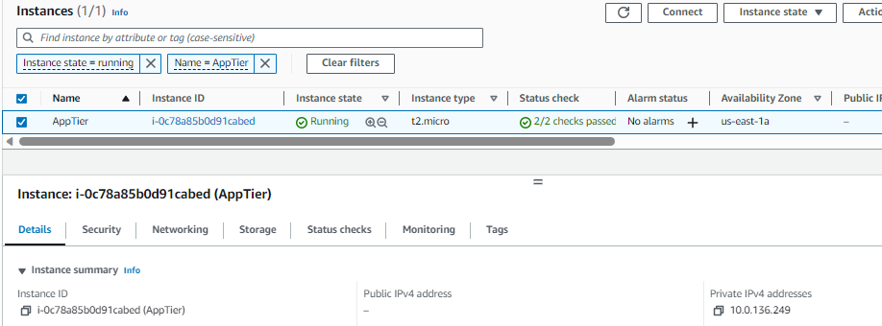

**Create a Launch Template and Auto Scaling Group**

Next, let’s create our application tier auto scaling group.

Navigate to the EC2 console and on the left side menu click “Auto Scaling Groups.” Make sure you create a new launch template since the security group permissions will be different for the application tier than they were for the web tier.

Use the same process we did before to create an auto scaling group, and it should look something like this:

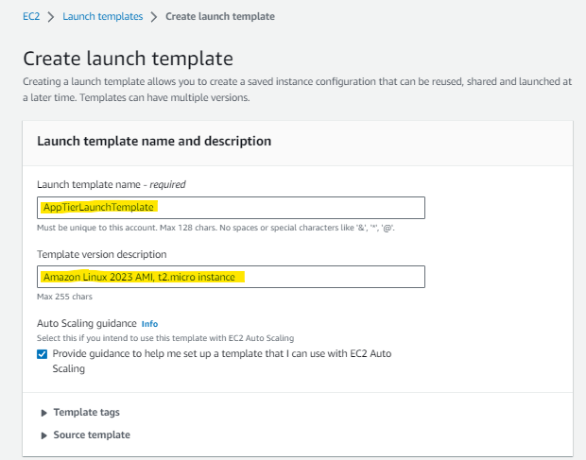

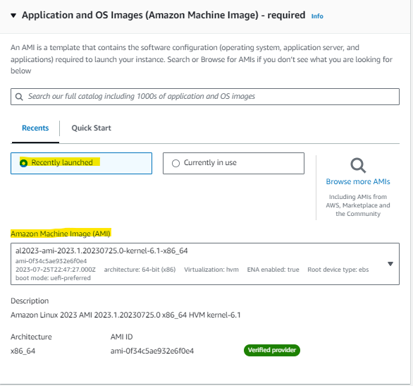

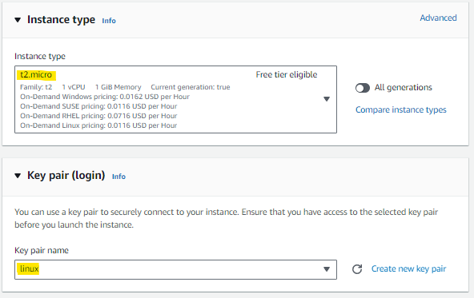

Under Network settings, select the application tier security group you created previously.

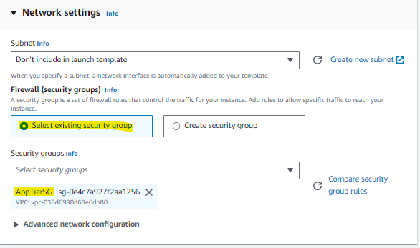

We aren’t adding any User data to this instance template, so go ahead and click “Create template.”

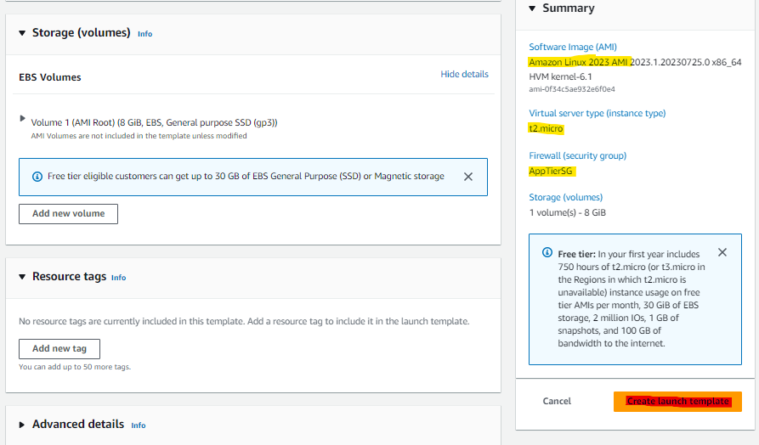

Now that our application tier launch template is created, let’s go create our application tier auto scaling group.

Navigate back to the EC2 console in the Create Auto Scaling group page refresh the launch templates. You should now see the application launch template you just created. Select the application template and click “Next.”

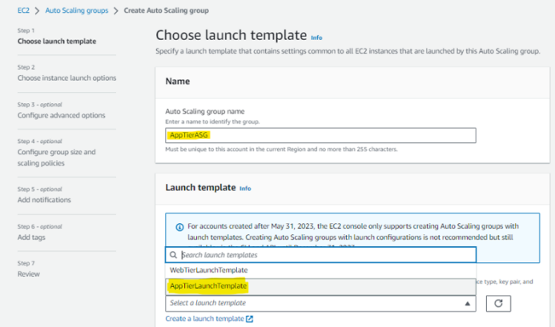

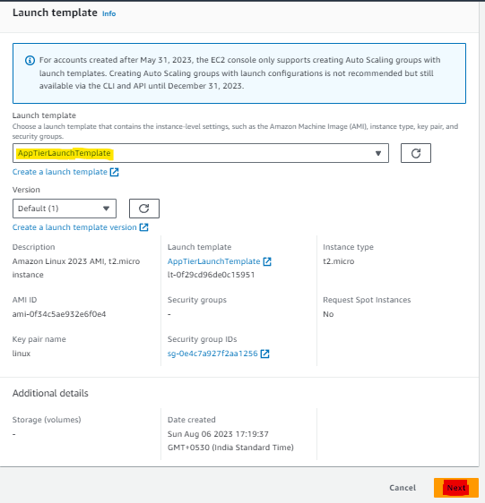

Choose the correct VPC and two of your private subnets (I used private-1-us-east-1a and private-2-us-east-1b).

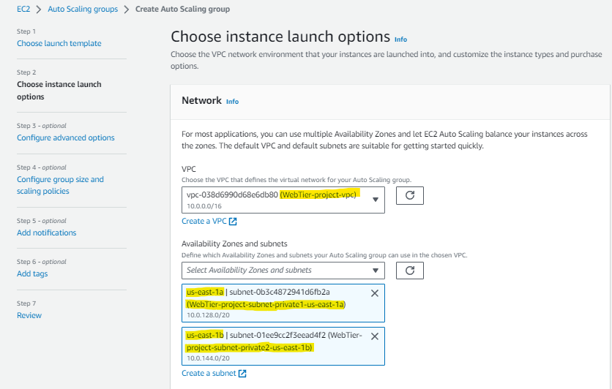

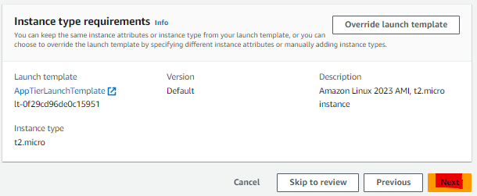

After clicking “Next,” you are given the option to select a load balancer. ***Since the application tier uses private subnets, we can select an internal application load balancer. Ensure that the VPC and private subnets look correct.***

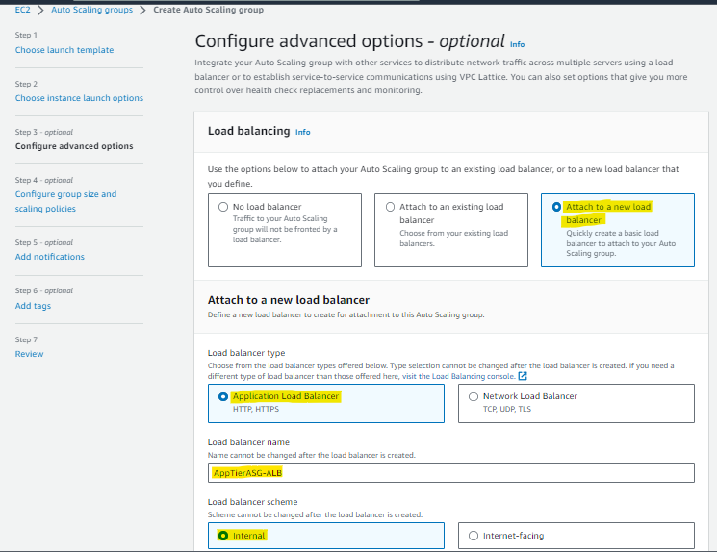

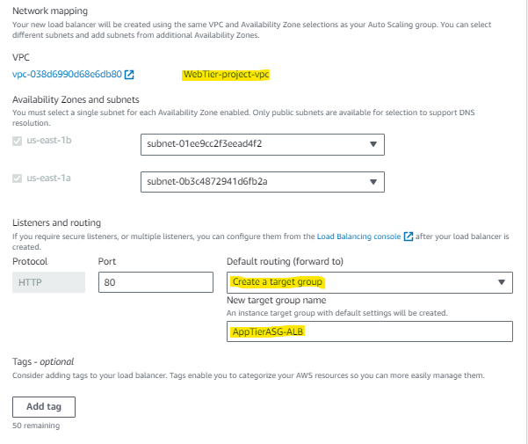

You have the option to include health checks and enable monitoring. Click “Next” to proceed

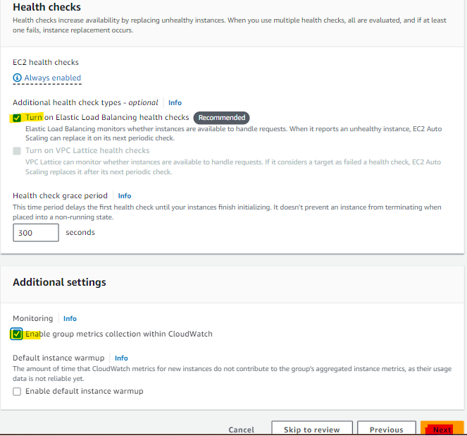

Choose how you want your application tier auto scaling group to scale. The configuration below will always keep one instance running and scale up to 2 when CPU utilization reaches 50%.

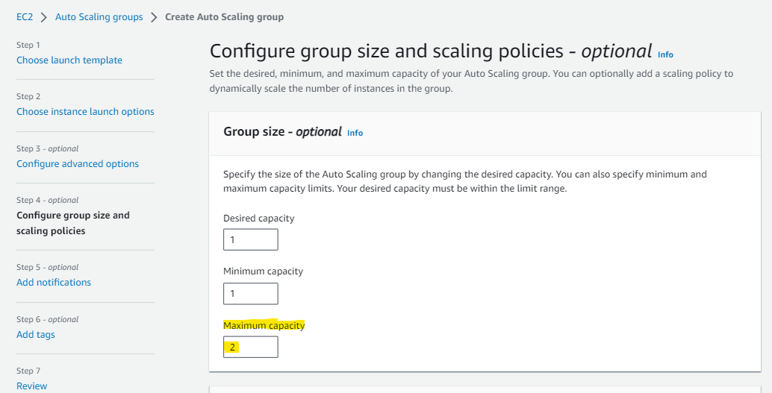

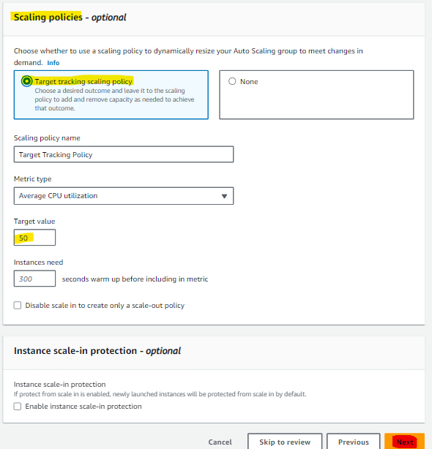

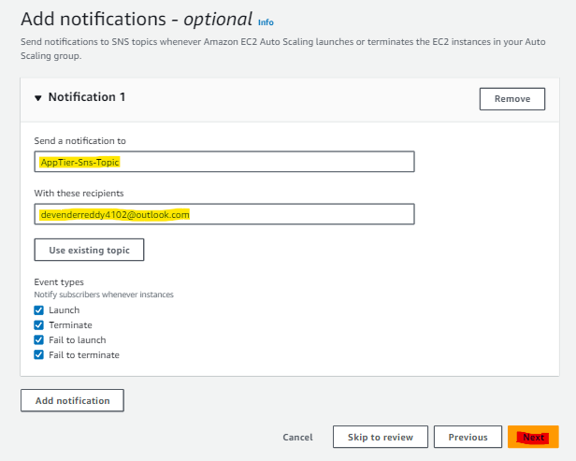

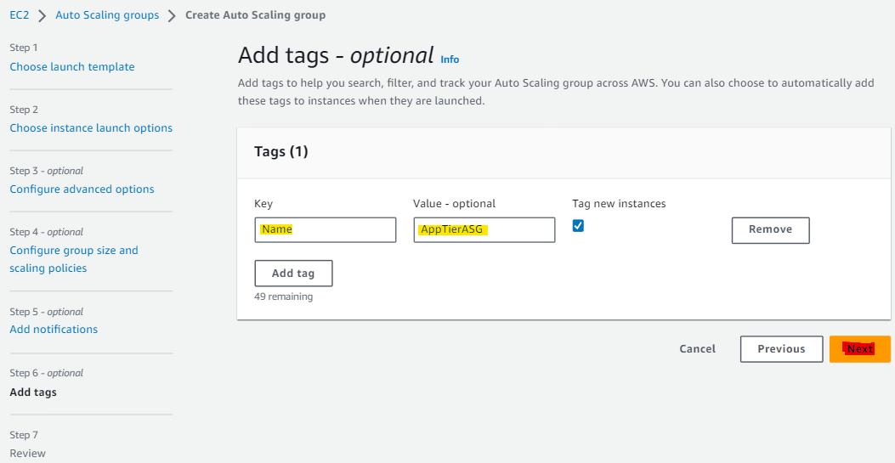

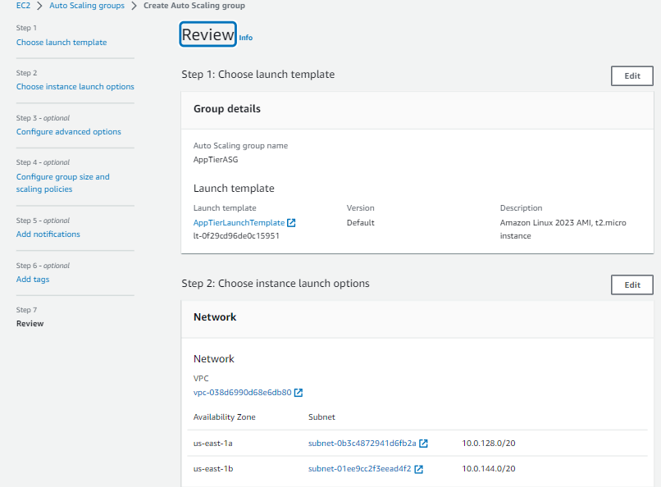 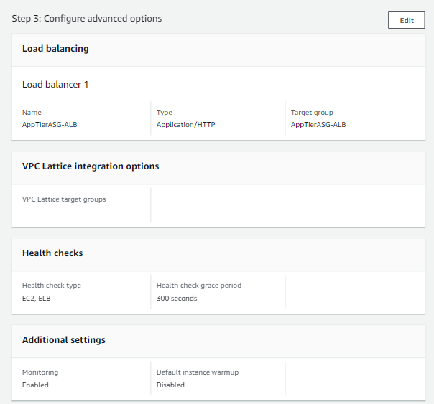

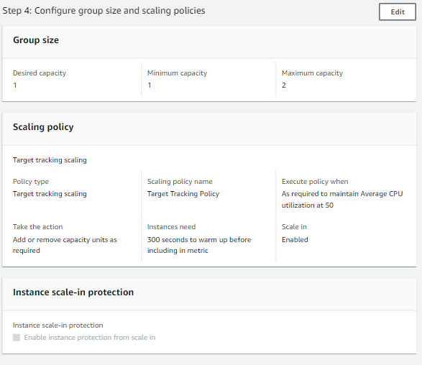 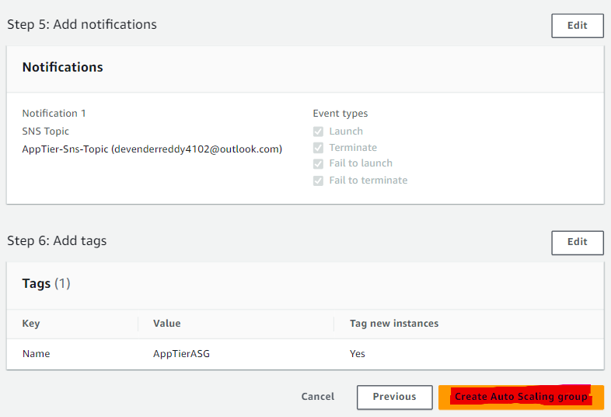

Click “Next.” Add notifications and tags if you want, then review your settings and click “Create Auto Scaling group.”

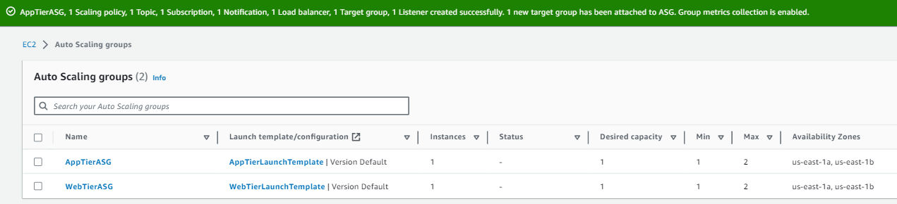

**Update Tier 2 Private Route Tables**

Navigate to the VPC console and on the left side menu select “Route tables.” Click one of your private route tables that was automatically created (mine is Demo-project-rtb-private1-us-east-1a) and look at the Subnet associations. Make sure this private route table is associated with two of the private subnets (I’ve chosen private-1-us-east-1a and private-2-us-east-1b).

**Part 4: Creating a Database Tier**

Alright guys, we’re in the home stretch. We have successfully created two of our three tiers, and now we want to focus on our database. AWS offers several different types of databases, but for this example we will use a MySQL RDS database.

**Create a DB Subnet Group**

The first thing we have to do is create our subnet groups, so navigate to the RDS console and on the left side menu click “Subnet Groups” and then the orange “Create DB subnet group.” This part can be a bit tricky so bear with me. Start by giving your database subnet group a name and description. Then select the VPC that we have been using for this entire tutorial.

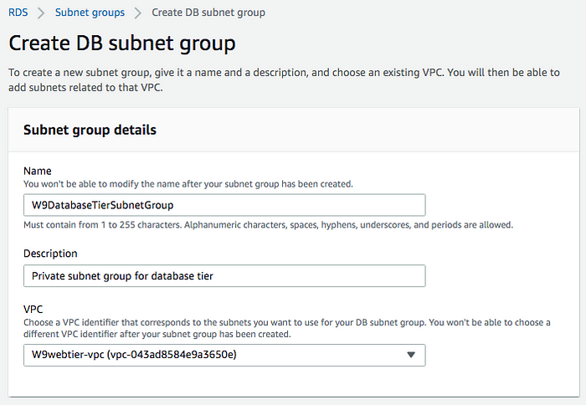

Here’s the tricky part. Under Add subnets, you must first select the availability zones. You need to know which availability zones you used previously to house your third and fourth private subnets. If you don’t remember, head over to the VPC console, click “Subnets” on the left side menu, and then select your last two private subnets (make sure not to select the private subnets that you already used in tier 2). On the subnet page you can see the availability zones used.

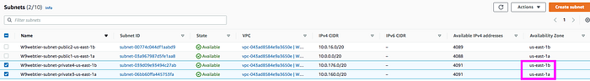

Now go back to the RDS Create DB subnet group page and you will see the Add subnets section.

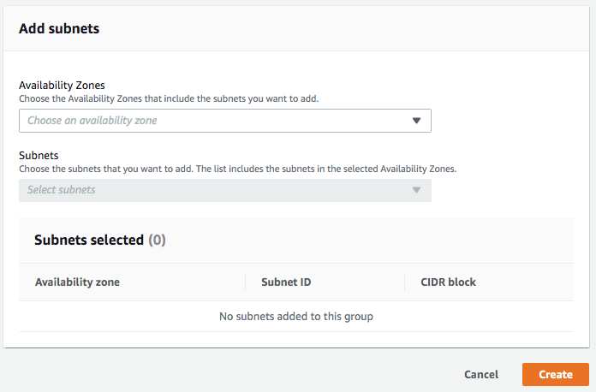

Select the availability zones that house your private subnets you’re going to use.

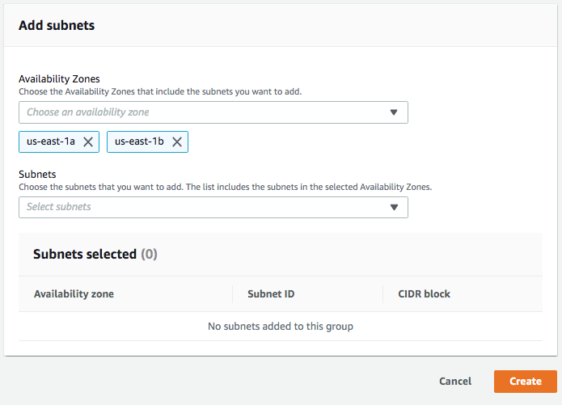

After selecting the correct availability zones, you can click the down arrow on Subnets to expand your available options.**This is the trickiest part.** Note that the subnets listed only show their subnet ID, not their name. You need to know the subnet ID of your last two private subnets so that you select the correct ones for tier 3. Go back to the VPC console and Subnets tab where you just found your availability zones, and grab the subnet IDs from there.

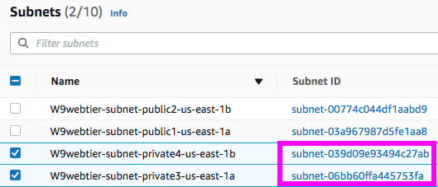

Once you have them, select them in the list and click “Create.”

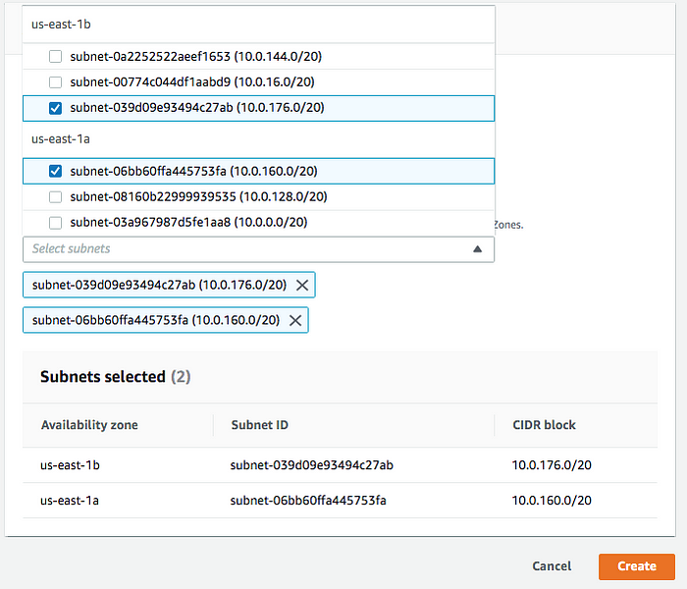

**Create a MySQL Database**

Your database subnet group is now created, so we can now click on “Databases” on the left side menu of the RDS console, and then “Create database.” Select “Standard create” and “MySQL.”

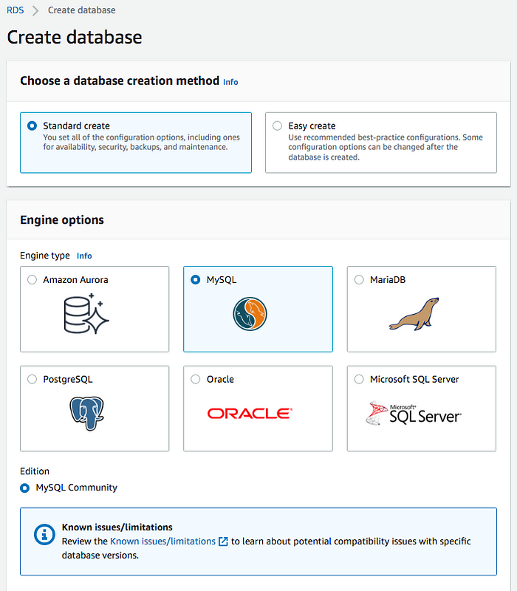

You have the option to create a multi-availability zone cluster that consists of three DB instances (one primary instance and two readable standby instances). This is very useful if a database instance fails, you have two backups ready to launch. For this example, we do not need this feature.

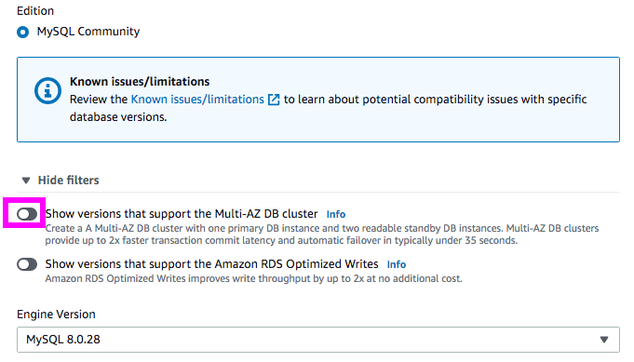

We will use the free tier template. If you were launching this database in Production mode or Dev/Test mode you would have access to the availability and durability deployment options. However, for our example, this is also not needed.

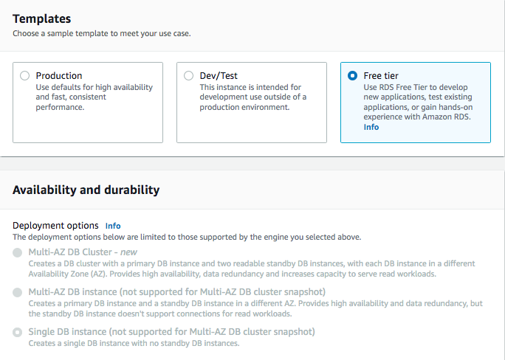

Under the Settings section, give the DB instance a name and create a master username and password for the database. This username and password should be different than your AWS account user login, as it is specific to the database you are creating.

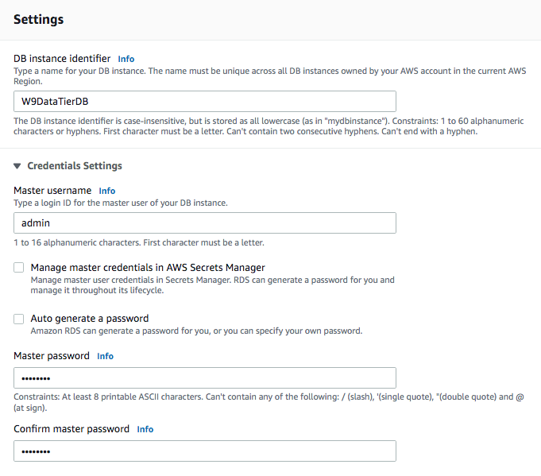

**\*Make sure you save your username and password. You will need it to connect to your database.\***

Under Instance configuration, the burstable classes option is the only one available for the free tier, thus it is pre-selected. You can adjust your instance type, and I’ve chosen db.t2.micro, which is enough for one VPC. Adjust storage as needed, but for this example I’ve left it as the default settings.

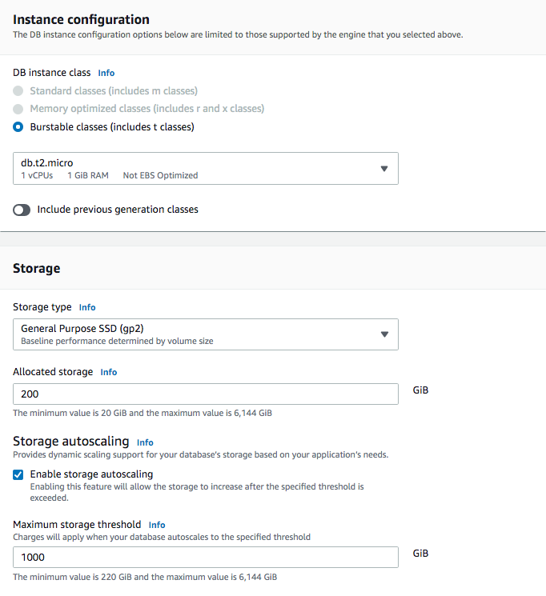

The next section is Connectivity and there are a lot of options here. Under Compute resource you can choose if you want to set up a connection to a compute resource for this database. This option automatically sets up your VPC and related network settings during database creation to enable a secure connection between the EC2 instance and the RDS database. For my example, I want to setup my network settings manually, so I’ve selected “Don’t connect to an EC2 compute resource.” The Network type is IPv4, and then you can select the VPC that we have been using for this tutorial. Next select the DB subnet group that you recently created. Since this is our company database and we don’t want the public accessing it, we’re going to select “No” for Public access. Under VPC security group, we want to create a new security group. Give the security group a name and select a preferred availability zone. You also have the option to create an RDS Proxy, but this does incur additional costs, so we will leave that option unselected.

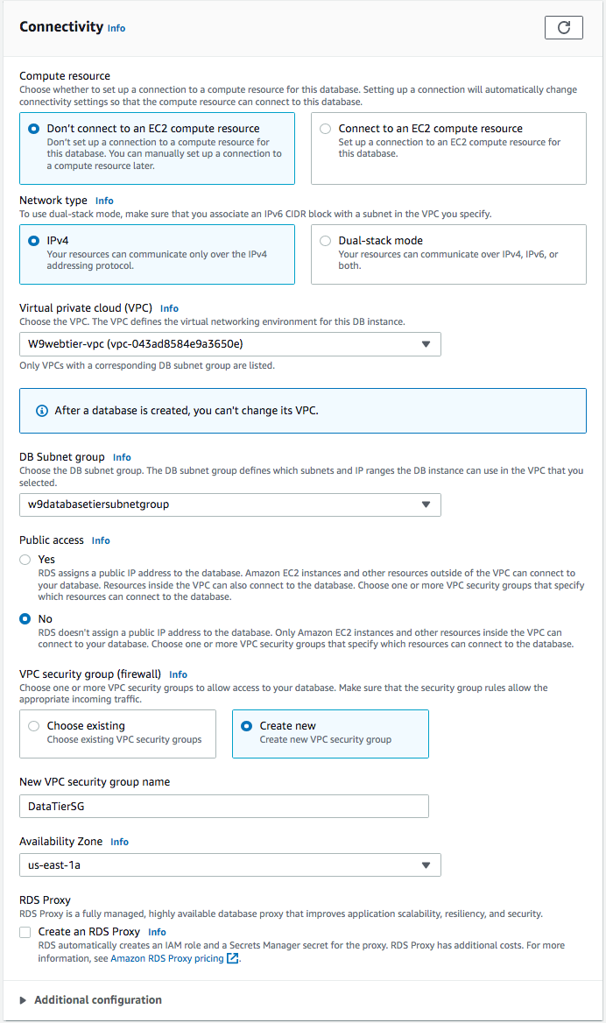

For Database authentication you have three options. Then you have the option for enhanced monitoring and additional configurations. When ready to proceed, click the “Create database” button.

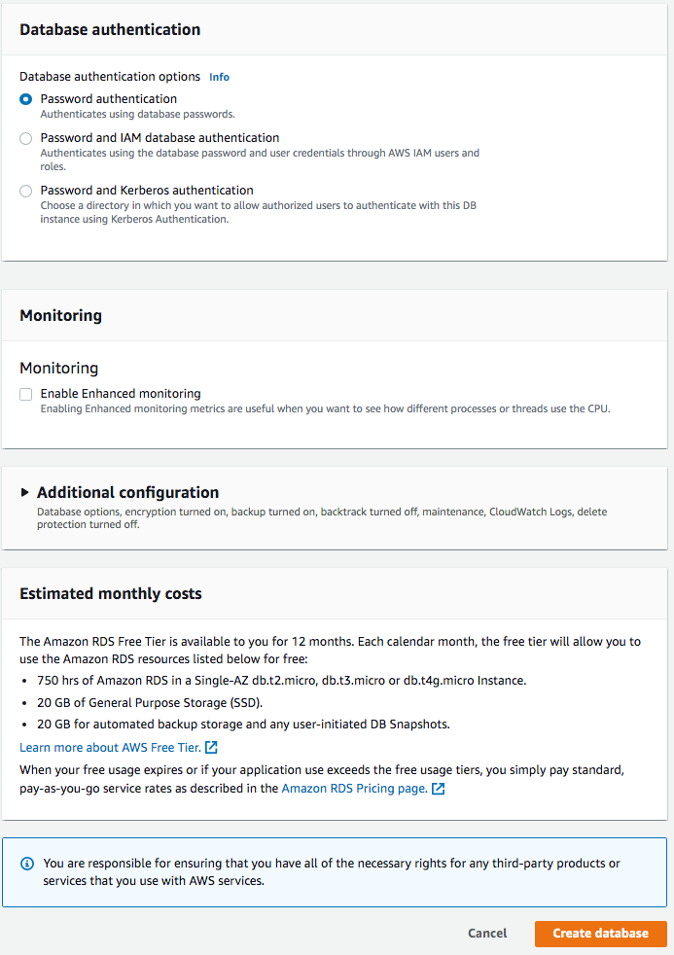

**Update Database Tier Security Group**

We created a new security group for the database tier, but weren’t given the opportunity to adjust the permissions. Navigate over to the VPC console, select Security groups on the left side menu, and then find the database tier security group you just created.

You can see that by default, the database security group has an inbound rule to allow MySQL/Aurora traffic on port 3306 from your IP address. Delete this rule.

We want to allow inbound traffic for MySQL from the application tier security group instead. Click “Add rule,” select “MySQL/Aurora” for Type (this will insert port 3306), choose custom Source, and then select your application tier security group and “Save rules.”

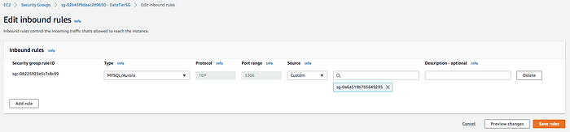

**Update Tier 3 Private Route Tables**

The last thing to do for the database tier is to adjust the route tables that were created by default earlier. Navigate to the VPC console and click “Route tables” on the left side menu. Select the private route table that you want to associate with your database tier private subnets, then click the Subnet associations tab to see if they are correctly associated. If the are not, you can edit subnet associations to add the correct subnets.

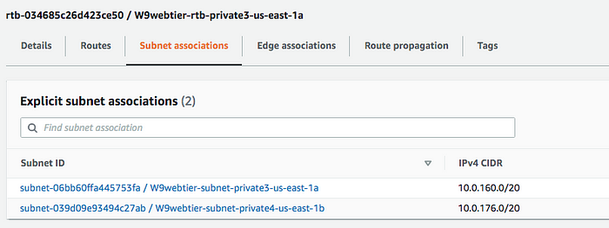



You did it! You created a three tier architecture. That was a lot of work. But we’re not done. Now that the architecture is built, let’s test it.

**Part 5: Testing Connectivity**

**SSH to Tier 1 Instance**

Let’s make sure we can connect to our web server instance via SSH:

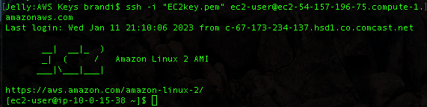

If we navigate to our tier 1 public IPv4 address, we’re greeted with this:

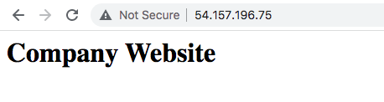

Perfect! Tier 1 is working.

**Ping Tier 2 from Tier 1**

Now test the application layer from tier 1. You are already logged into the tier 1 instance, so try to ping the tier 2 private IPv4 address.

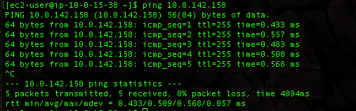

That works also, so we know our tier 1 and tier 2 are able to communicate.

**Analyzing Reachability**

Navigate to the VPC console and click on Security groups. Open your web tier security group and click “Run Reachability Analyzer.”

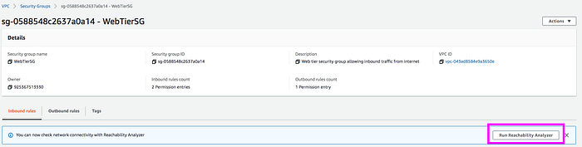

In the analyzer, you create a path to determine if it is reachable. Our first path will test the reachability of the tier 1 instance to the tier 2 instance (similar to what we did in the CLI). Under Source type select “Instances” and under Source select the web server tier 1 instance. Under Destination type select “Instances” and for Destination choose the application tier 2 instance. Then click “Create and analyze path.”

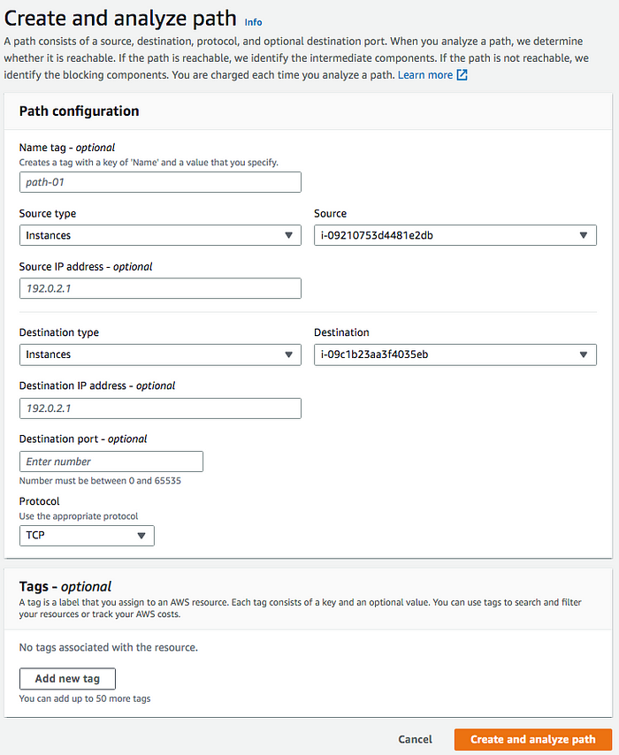

This may take several minutes to complete, but if it succeeds, you will get a green “Reachable” and “Succeeded” status.

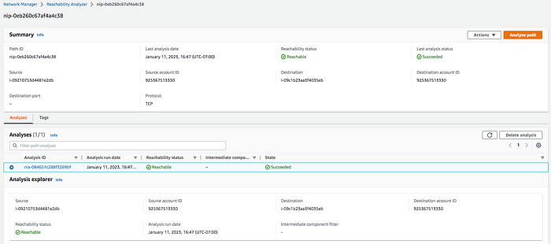

**Analyze Tier 2 and Tier 3 Reachability**

In tier 3 we created a DB instance, which is an isolated database environment running in the cloud. Don’t confuse a DB instance with an EC2 instance. We can’t directly SSH to the database, but we can use an SSH forwarding agent to achieve this.

**Accessing Private Subnet From a Public Subnet**You need to add your access key pair file to your keychain. To do this, first make sure you are in your local host (use the command *exit* to get out of any EC2 instance you’re connected to). Then use the following command:

ssh-add -K <keypair.pem>

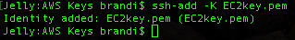

The output should be “Identity added.” Now that your key pair file is added to your keychain, SSH agent will scan through all of the keys associated with the keychain and find your matching key.

Now we can reconnect to our public web tier 1 EC2 instance via SSH, but this time use -A to specify you want to use the SSH agent.

ssh -A ec2-user@<public-ip-address>

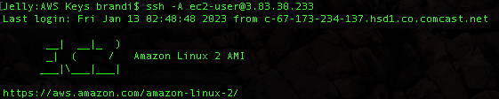

Now that you are logged back into your public instance, check to make sure that SSH agent forwarded the private key to the instance. Use the following command to do this. Note that the output says error fetching identities, but then the private key is listed in the following line (I’ve grayed out my key for security purposes):

ssh-add -l



Ok so our key pair has been forwarded to our public instance, so let’s see if we can now connect to our private instance. Grab your application tier 2 private IPv4 address and input it into the following command:

ssh -A ec2-user@<private-ip-address>

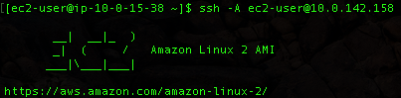

You have now SSH’d from your public tier 1 web instance into your private tier 2 application instance!

**Testing Connectivity to the Database Tier**There are a few ways you can connect to your RDS database from your application tier. One way is to install MySQL on your private tier 2 instance to access your database. Make sure you are still logged into your tier 2 application instance, and use the following command:

sudo yum install mysql -y

This actually installs the MariDB package, which is used to read MySQL. Once this is installed, you should be able to use the following command to log into your RDS MySQL database. Before typing the command, you will need your RDS database endpoint and the username and password you created when you created the RDS database. To find your RDS database endpoint, navigate to the database you created and find the endpoint under Connectivity & Security.

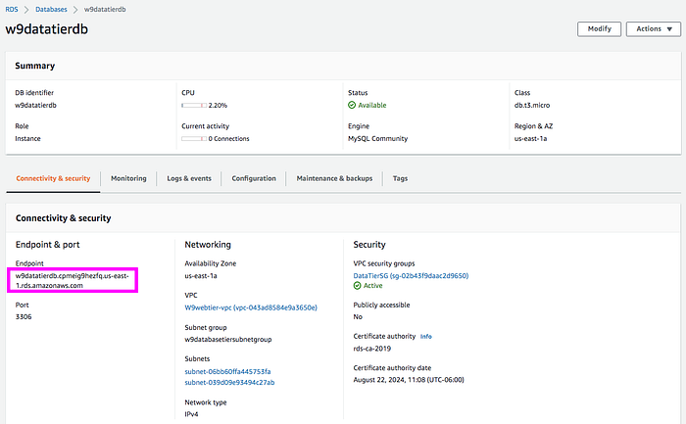

If you forgot your username, you can find it by going to the Configuration tab in the RDS database.

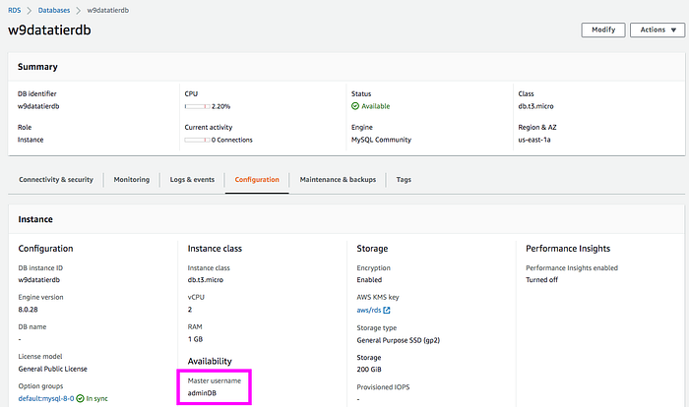

Good luck if you forgot your password. Seriously, I don’t know how you can recover it. Ok now we are ready to connect to our database from the CLI. Use the following command:

mysql -h <rds-database-endpoint> -P 3306 -u <username> -p

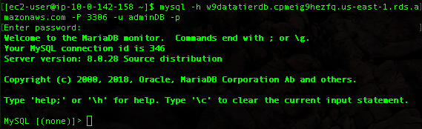

You are now connected to your MySQL database from your application tier. All of your tiers have connectivity!

This project was a labor of love and not without its challenges, particularly testing the connectivity. I hope it helps someone, and if you have questions about a particular step, please comment below and I will try to help out.

***\*REMEMBER* When done with this session, make sure to delete your resources that cost money, including your NAT gateway, elastic IP, and ALBs. Stop your instances to prevent them from running up unnecessary costs.***